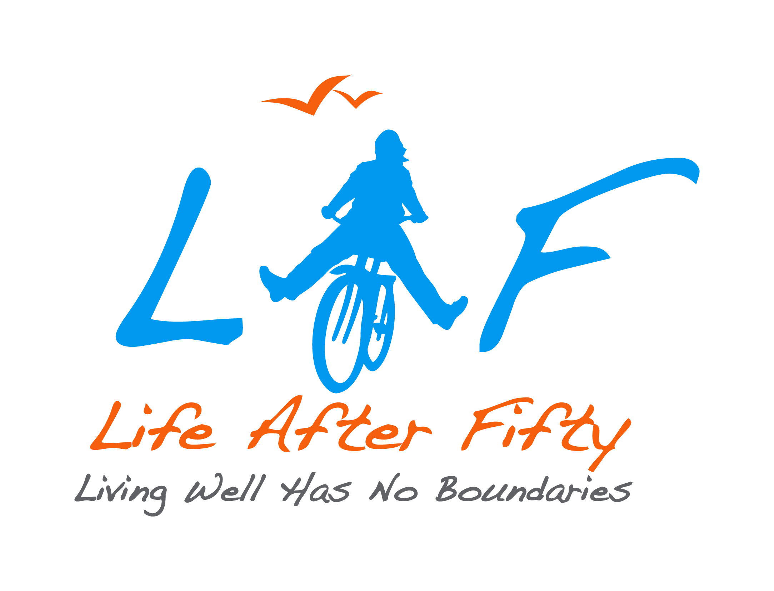

LIFE AFTER FIFTY
635 McEwan
Windsor, Ontario N9B 2E9

JOB DESCRIPTION –
OUTREACH COORDINATOR, Promoting Seniors’ Independence

Position: Outreach Coordinator

Status: Contract Part-time

Reports to: Director of Programs & Services

Salary Range:

Position Summary:

The Outreach Coordinator is responsible for the planning, delivery and evaluation of outreach programs within the guidelines of the United Way approved work plan. Outreach programs are delivered in seniors’ designated apartment buildings and gathering places throughout the City of Windsor and Essex County.

Key Responsibilities

- Responsible for the planning, delivery and evaluation of outreach programs:

- Assess the education needs and activity interests of residents/tenants in each apartment building

- Develop relationships with tenant associations, building managers and community relations workers in each building

- Lead the development of monthly outreach activities schedules for each apartment building in consultation with Director of Programs and Services.

- Assist with the preparation of grant applications, as applicable.

- Develop peer support models and leaders within apartment buildings

- Responsible for programming costs in collaboration with Director of Programs & Services.

- Develop and implement mechanisms to obtain feedback on programs

- Assist in preparation of reports to funders

- Responsible for partnership development:

- Identify and develop relationships with community partners to deliver programs appropriate for outreach services.

- Meet with community partners on a regular basis to ensure positive working relationships and to receive feedback on outreach services

- Responsible for the publicity specifically required to promote outreach services:

- Providing information regarding outreach programs and activities and LAF programs.

- Development of promotional material as needed.

- Network with community and share information about activities and services for older adults.

- Responsible for supporting student/program volunteers:

- Identify and develop volunteer opportunities within outreach services in collaboration with Volunteer Coordinator

- Nurture and support and evaluate volunteers

- Provide supervision for students on placement who have been assigned to outreach services

Qualifications

- Degree/Diploma in social work, social service work, community or recreation programming field, or combination of relevant education and experience
- Experience working with older adults,
- Experience coordinating development of programs,
- Extensive knowledge of community resources,
- Ability to develop partnerships,
- Excellent oral, written and electronic communication skills

Conditions of Employment
- Police clearance required
- Driver’s license

